**ASSIGNMENT (MODUL-2)**

**CSS AND CSS3**

**• What are the benefits of using CSS?**

1) Faster Page Speed. More code means slower page speed. ...

2) Better User Experience. CSS not only makes web pages easy on the eye, it also allows for user-friendly formatting. ...

3) Quicker Development Time. ...

4) Easy Formatting Changes. ...

5) Compatibility Across Devices.

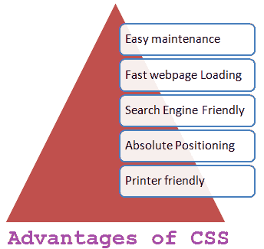

**• What are the disadvantages of CSS?**

* Confusion due to many CSS levels. Beginners are more vulnerable to this issue. ...
* Cross-Browser Issues. Different browsers work differently. ...
* Security Issues. Security is important in today's world driven by technology and data.
* Extra Work for Developers.

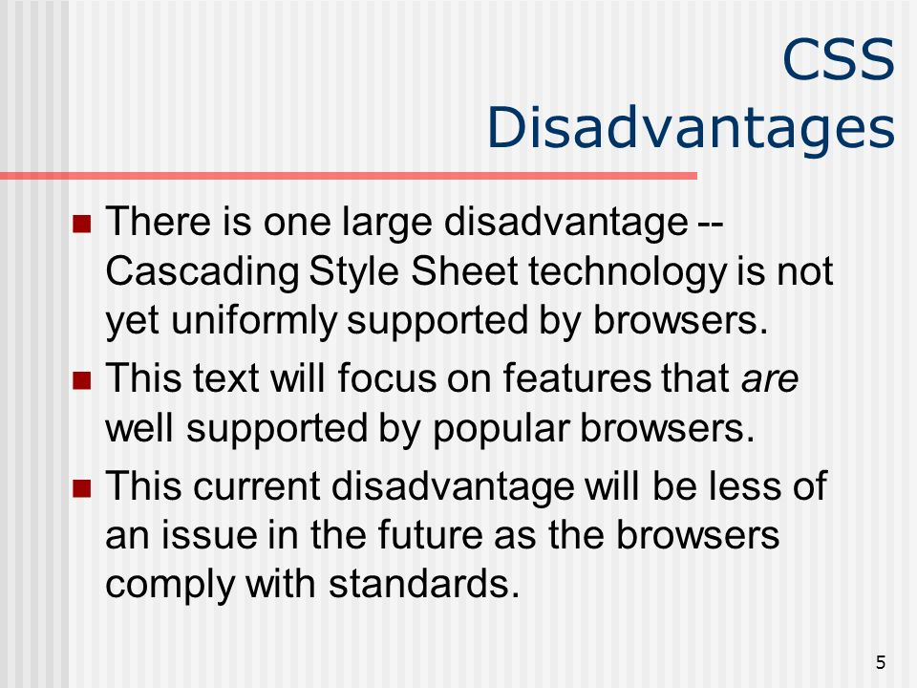

**• What is the difference between CSS2 and CSS3?**

The biggest difference between CSS2 and CSS3 is that **CSS3 is now split into different modules**. Since each module makes its way through the W3C individually, there's a wider range of browser support. Make sure you test your CSS3 pages in as many browsers and operating systems as possible to ensure compatibility.

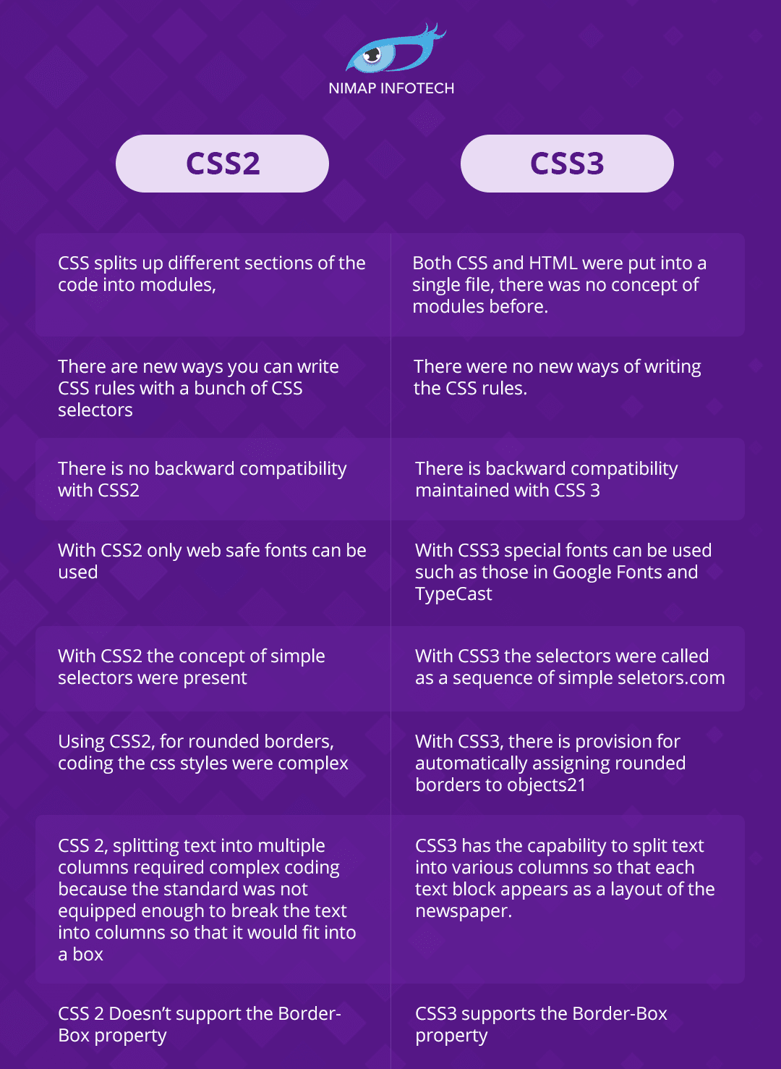

**• Name a few CSS style components**

**At its most basic level, CSS consists of two components:**

* Properties: These are human-readable identifiers that indicate which stylistic features you want to modify. For example, font-size, width, background-color .
* Values: Each property is assigned a value. This value indicates how to style the property.

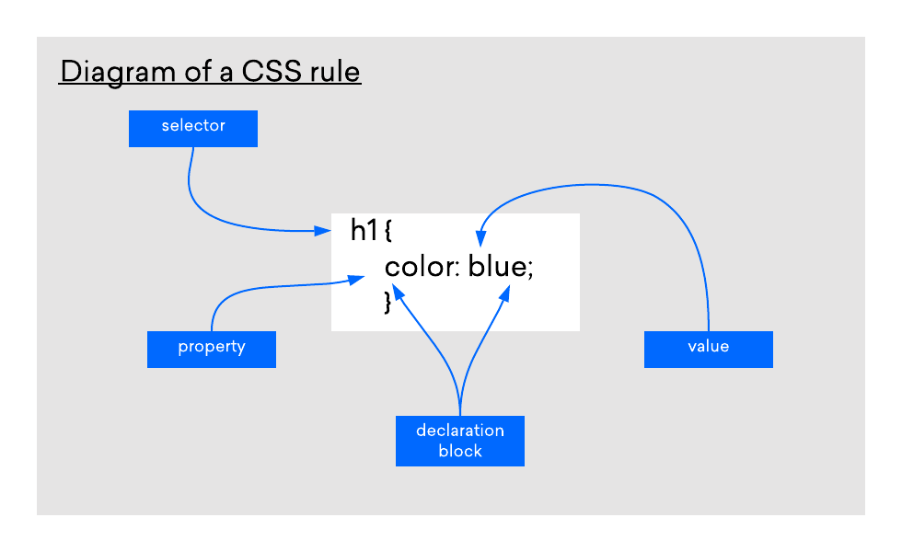

**• What do you understand by CSS opacity?**

The opacity CSS property sets the opacity of an element. Opacity is **the degree to which content behind an element is hidden, and is the opposite of transparency**.

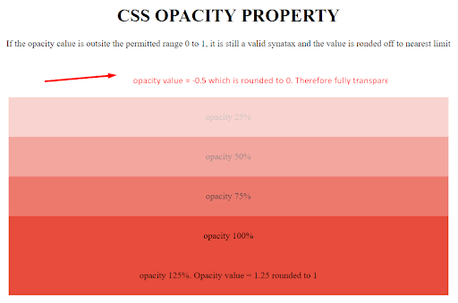

**• How can the background color of an element be changed?**

To add background color in HTML, **use the CSS background-color property**. Set it to the color name or code you want and place it inside a style attribute. Then add this style attribute to an HTML element, like a table, heading, div, or span tag.

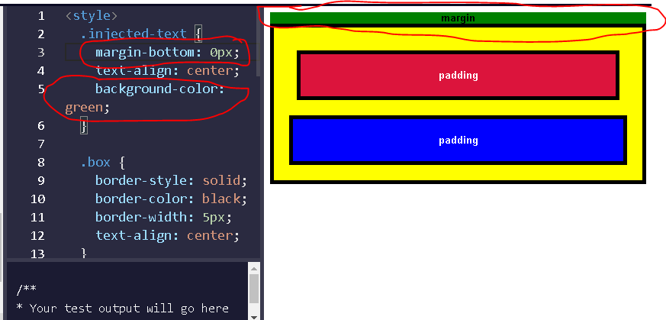

**• How can image repetition of the backup be controlled?**

 We will see how an image repetition of the backup is controlled in CSS. This task can be achieved by using the *background-repeat property* that will help us to control the repetition of the image.

The **background-repeat property** in CSS is used to repeat the background image both horizontally and vertically. It also decides whether the background image will be repeated or not.

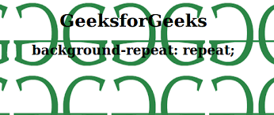

**• What is the use of the background-position property?**

The background-position property **sets the starting position of a background image**. Tip: By default, a background-image is placed at the top-left corner of an element, and repeated both vertically and horizontally.

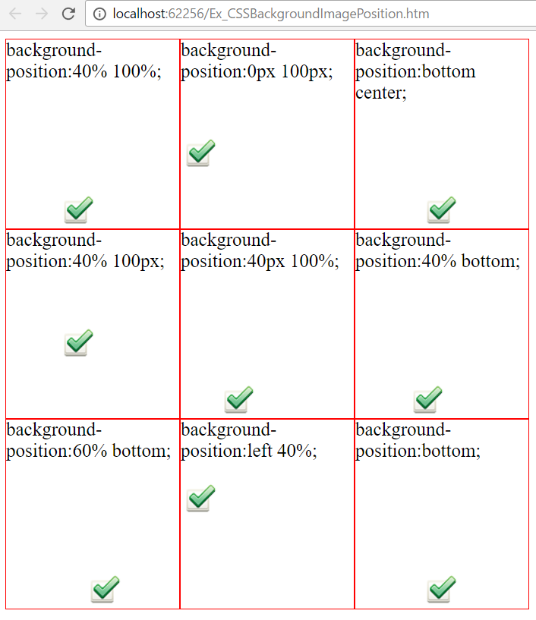

**• Which property controls the image scroll in the background?**

The background-attachment property sets whether a background image scrolls with the rest of the page, or is fixed.

To set the scrolling of an image in the background, use the background-attachment property.

Example

A background-image that will not scroll with the page (fixed):

body {  
  background-image: url("img_tree.gif");  
  background-repeat: no-repeat;  
  background-attachment: fixed;  
}

**• Why should background and color be used as separate properties?**

There are two reasons behind this: **It enhances the legibility of style sheets**. The background property is a complex property in CSS, and if it is combined with color, the complexity will further increase.

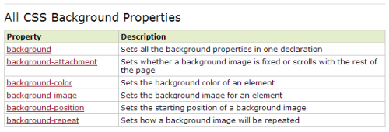

**• How to center block elements using CSS1?**

There are two ways of centering block level elements:  
  
1. By setting the properties margin-left and margin-right to auto and width to some explicit value:  
  
BODY {width: 30em; background: cyan;}  
P {width: 22em; margin-left: auto; margin-right: auto}  
  
In this case, the left and right margins will each be four ems wide, since they equally split up the eight ems left over from (30em - 22em). Note that it was not necessary to set an explicit width for the BODY element; it was done here to keep the math clean.

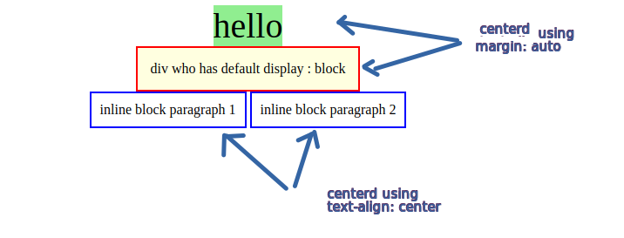

**• How to maintain the CSS specifications?**

The Specification defines how CSS properties should be implemented by browser vendors along with detailed algorithms, code samples and tabular information.

The Specification also include:

* The syntax and data types of the language
* Detailed explanation on CSS Selectors
* How you can assign values to properties
* The Cascade (the "C" in CSS)
* How inheritance works
* The Box Model etc.

The Specification also specify how stylesheets can be included in your web document and how to target specific media e.g. print or screen

**• What are the ways to integrate CSS as a web page?**

CSS can be added to HTML documents in 3 ways: **Inline - by using the style attribute inside HTML elements**. Internal - by using a <style> element in the <head> section. External - by using a <link> element to link to an external CSS file.

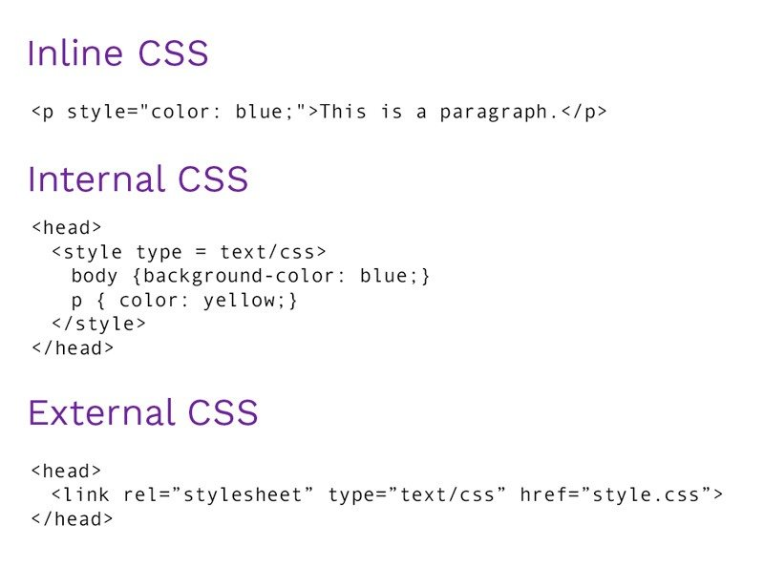

**• What is embedded style sheets?**

Embedded style sheets **allow you to define styles for the whole HTML document in one place**. Embedded style sheets refer to when you embed style sheet information into an HTML document using the <style> element. You do this by embedding the style sheet information within <style></style> tags in the head of your document.

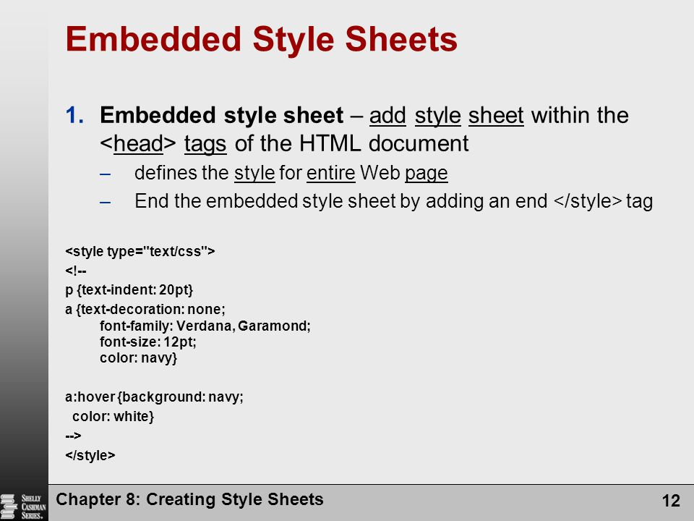

**• What are the external style sheets?**

An external style sheet is **a separate CSS file that can be accessed by creating a link within the head section of the webpage**. Multiple webpages can use the same link to access the stylesheet. The link to an external style sheet is placed within the head section of the page.

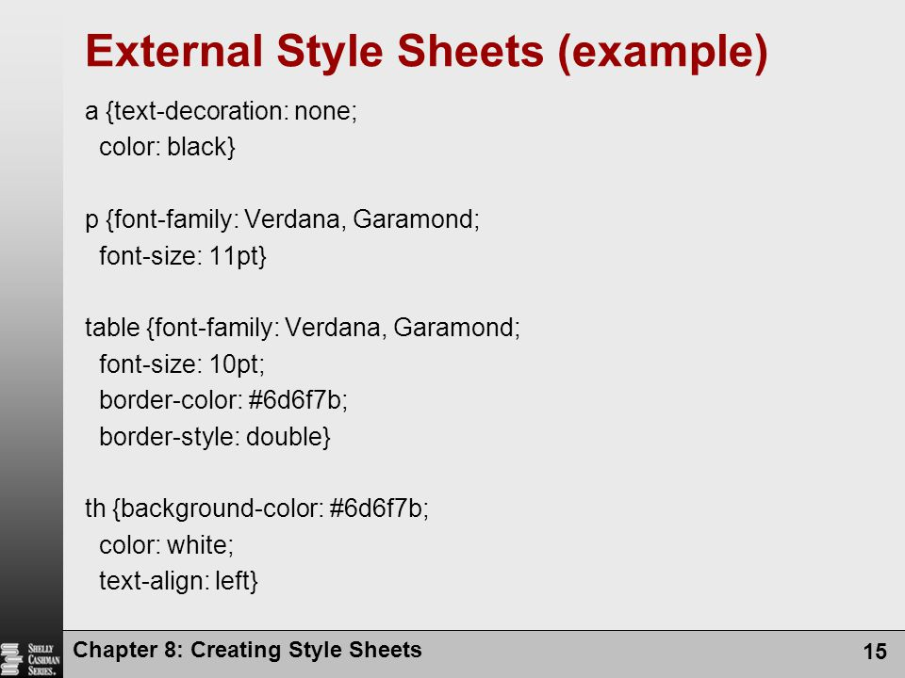

**• What are the advantages and disadvantages of using external style sheets?**

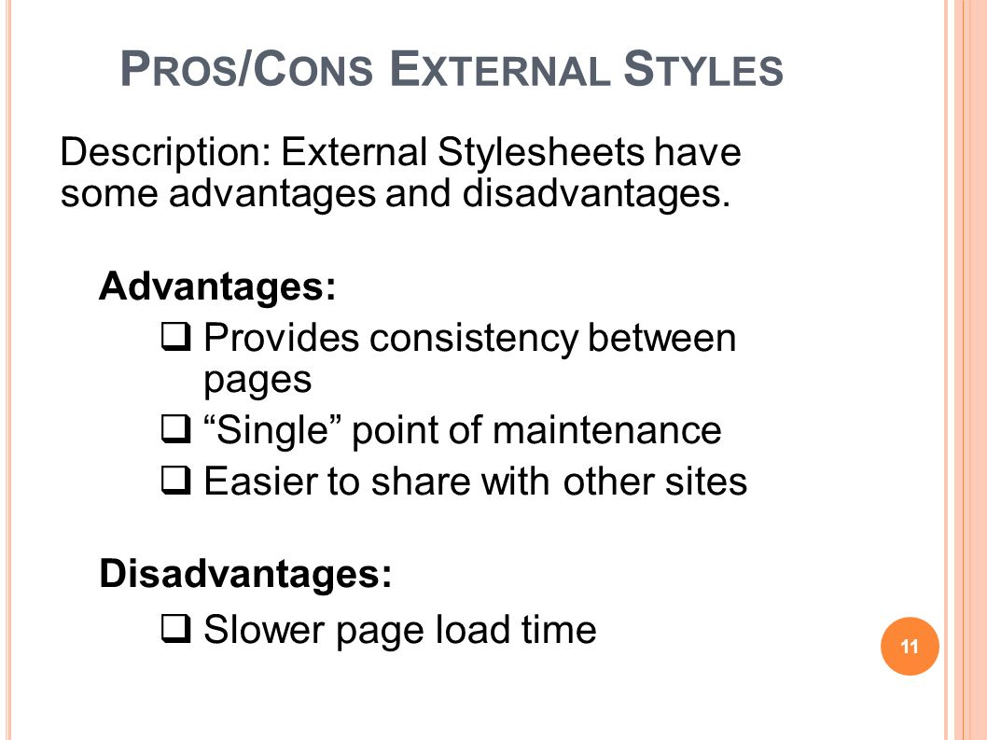

**• What is the meaning of the CSS selector?**

A CSS selector is the first part of a CSS Rule. It is **a pattern of elements and other terms that tell the browser which HTML elements should be selected to have the CSS property values inside the rule applied to them**.

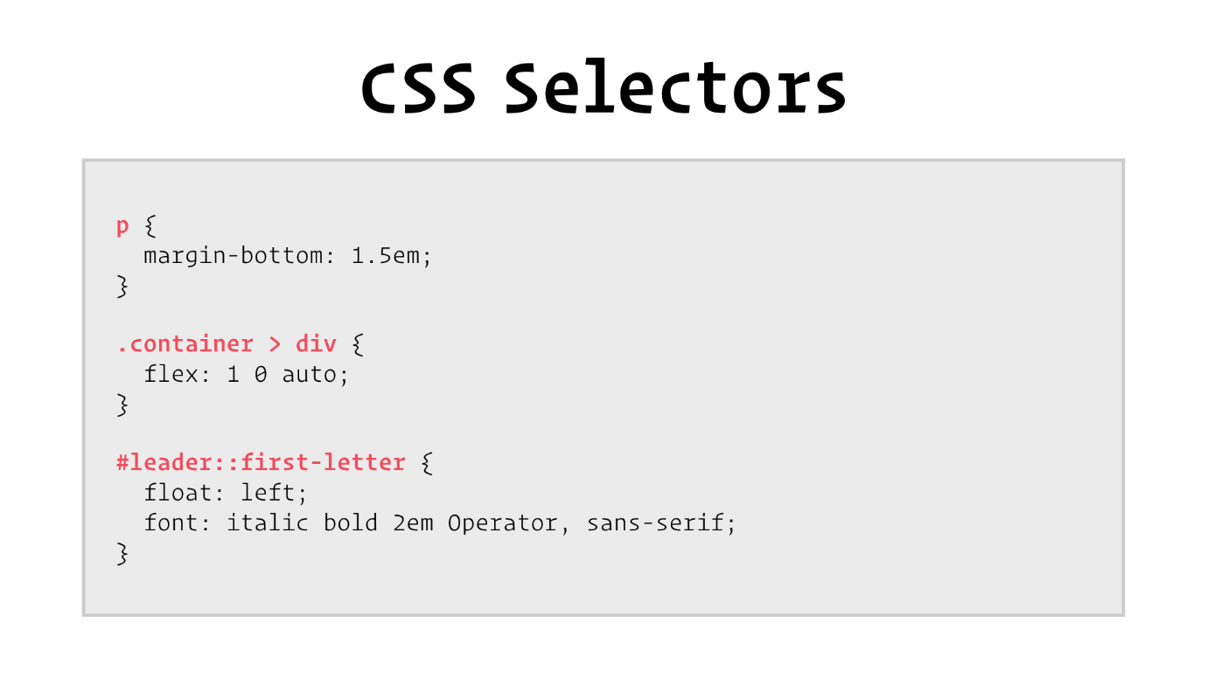

**• What are the media types allowed by CSS?**

The names chosen for CSS media types reflect target devices for which the relevant properties make sense. In the following list of CSS media types the names of media types are normative, but the descriptions are informative. Likewise, the "Media" field in the description of each property is informative.

**all**

Suitable for all devices.

**braille**

Intended for braille tactile feedback devices.

**embossed**

Intended for paged braille printers.

**handheld**

Intended for handheld devices (typically small screen, limited bandwidth).

**print**

Intended for paged material and for documents viewed on screen in print preview mode. Please consult the section on [paged media](https://www.w3.org/TR/CSS21/page.html) for information about formatting issues that are specific to paged media.

**projection**

Intended for projected presentations, for example projectors. Please consult the section on [paged media](https://www.w3.org/TR/CSS21/page.html) for information about formatting issues that are specific to paged media.

**screen**

Intended primarily for color computer screens.

**speech**

Intended for speech synthesizers. Note: CSS2 had a similar media type called 'aural' for this purpose. See the appendix on [aural style sheets](https://www.w3.org/TR/CSS21/aural.html) for details.

**tty**

Intended for media using a fixed-pitch character grid (such as teletypes, terminals, or portable devices with limited display capabilities). Authors should not use [pixel units](https://www.w3.org/TR/CSS21/syndata.html#length-units) with the "tty" media type.

**tv**

Intended for television-type devices (low resolution, color, limited-scroll ability screens, sound available).

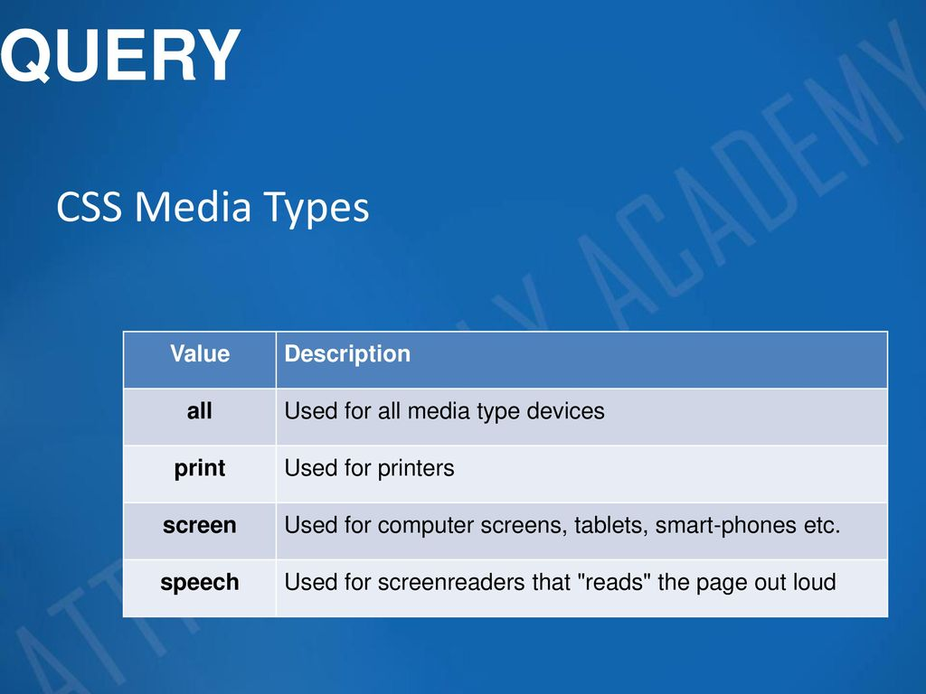

* **What is the rule set?**

A CSS rule set **contains one or more selectors and one or more declarations**. The selector(s), which in this example is h1 , points to an HTML element. The declaration(s), which in this example are color: blue and text-align: center style the element with a property and value.

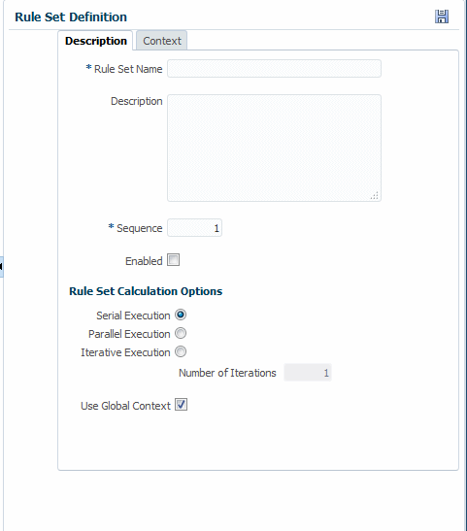

**• Create Layouts**

**http://127.0.0.1:5500/Untitled-1%20box%20layout%201.html**